**Regions**

A region is a set of datacenters deployed within a latency-defined perimeter and connected through a dedicated regional low-latency network.

**55**

regions  
worldwide

**140**

available in  
140 countries

### Geographies

A geography is a discrete market, typically containing two or more regions, that preserves data residency and compliance boundaries.

Geographies allow customers with specific data-residency and compliance needs to keep their data and applications close. Geographies are fault-tolerant to withstand complete region failure through their connection to our dedicated high-capacity networking infrastructure.

### Availability Zones

Availability Zones are physically separate locations within an Azure region. Each Availability Zone is made up of one or more datacenters equipped with independent power, cooling, and networking.

Availability Zones allow customers to run mission-critical applications with high availability and low-latency replication.

## Terminology

If you're new to Azure Resource Manager, there are some terms you might not be familiar with.

* **resource** - A manageable item that is available through Azure. Virtual machines, storage accounts, web apps, databases, and virtual networks are examples of resources.
* **resource group** - A container that holds related resources for an Azure solution. The resource group includes those resources that you want to manage as a group. You decide which resources belong in a resource group based on what makes the most sense for your organization. See [Resource groups](https://docs.microsoft.com/en-us/azure/azure-resource-manager/management/overview#resource-groups).
* **resource provider** - A service that supplies Azure resources. For example, a common resource provider is Microsoft.Compute, which supplies the virtual machine resource. Microsoft.Storage is another common resource provider. See [Resource providers and types](https://docs.microsoft.com/en-us/azure/azure-resource-manager/management/resource-providers-and-types).
* **Resource Manager template** - A JavaScript Object Notation (JSON) file that defines one or more resources to deploy to a resource group or subscription. The template can be used to deploy the resources consistently and repeatedly. See [Template deployment overview](https://docs.microsoft.com/en-us/azure/azure-resource-manager/templates/overview).
* **declarative syntax** - Syntax that lets you state "Here is what I intend to create" without having to write the sequence of programming commands to create it. The Resource Manager template is an example of declarative syntax. In the file, you define the properties for the infrastructure to deploy to Azure. See [Template deployment overview](https://docs.microsoft.com/en-us/azure/azure-resource-manager/templates/overview).

# Identity and access management (IAM)

## Add a new user

You can create a new user using the Azure Active Directory portal.

To add a new user, follow these steps:

1. Sign in to the [Azure portal](https://portal.azure.com/) as a User administrator for the organization.
2. Search for and select Azure Active Directory from any page.
3. Select **Users**, and then select **New user**.

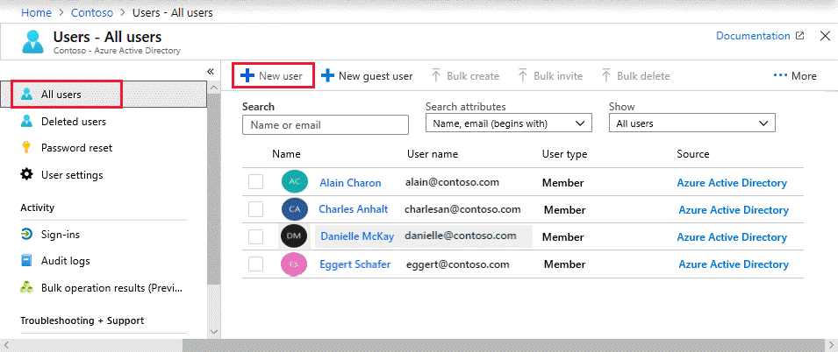

1. On the **User** page, enter information for this user:
   * **Name**. Required. The first and last name of the new user. For example, Mary Parker.
   * **User name**. Required. The user name of the new user. For example, mary@contoso.com.

The domain part of the user name must use either the initial default domain name, <yourdomainname>.onmicrosoft.com, or a custom domain name, such as contoso.com. For more information about how to create a custom domain name, see [Add your custom domain name using the Azure Active Directory portal](https://docs.microsoft.com/en-us/azure/active-directory/fundamentals/add-custom-domain).

* + **Groups**. Optionally, you can add the user to one or more existing groups. You can also add the user to groups at a later time. For more information about adding users to groups, see [Create a basic group and add members using Azure Active Directory](https://docs.microsoft.com/en-us/azure/active-directory/fundamentals/active-directory-groups-create-azure-portal).
  + **Directory role**: If you require Azure AD administrative permissions for the user, you can add them to an Azure AD role. You can assign the user to be a Global administrator or one or more of the limited administrator roles in Azure AD. For more information about assigning roles, see [How to assign roles to users](https://docs.microsoft.com/en-us/azure/active-directory/fundamentals/active-directory-users-assign-role-azure-portal).
  + **Job info**: You can add more information about the user here, or do it later. For more information about adding user info, see [How to add or change user profile information](https://docs.microsoft.com/en-us/azure/active-directory/fundamentals/active-directory-users-profile-azure-portal).

1. Copy the autogenerated password provided in the **Password** box. You'll need to give this password to the user to sign in for the first time.
2. Select **Create**.

### To assign a role to a user

1. Go to the [Azure portal](https://portal.azure.com/) and log in using a Global administrator account for the directory.
2. Search for and select **Azure Active Directory**.

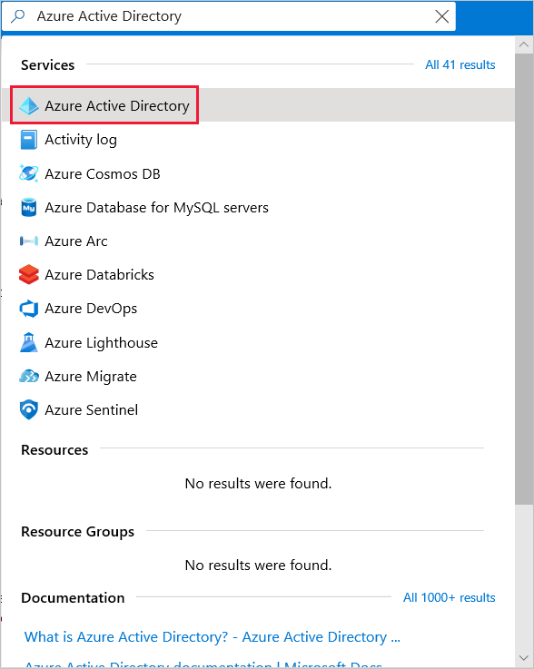

1. Select **Users**.
2. Search for and select the user getting the role assignment. For example, Alain Charon.

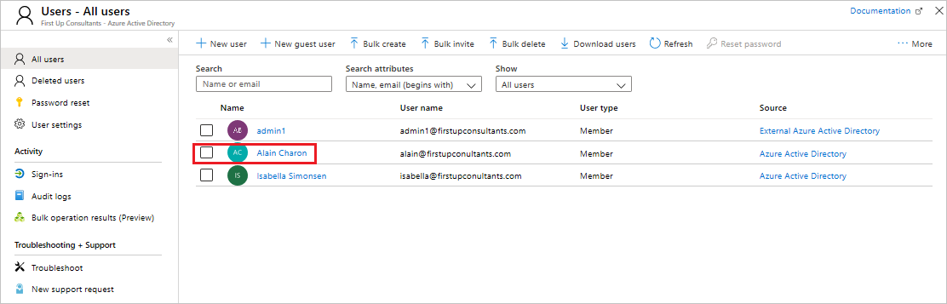

1. On the **Alain Charon - Profile** page, select **Assigned roles**.

The **Alain Charon - Directory role** page appears.

1. Select **Add assignment**, select the role to assign to Alain (for example, Application administrator), and then choose **Select**.

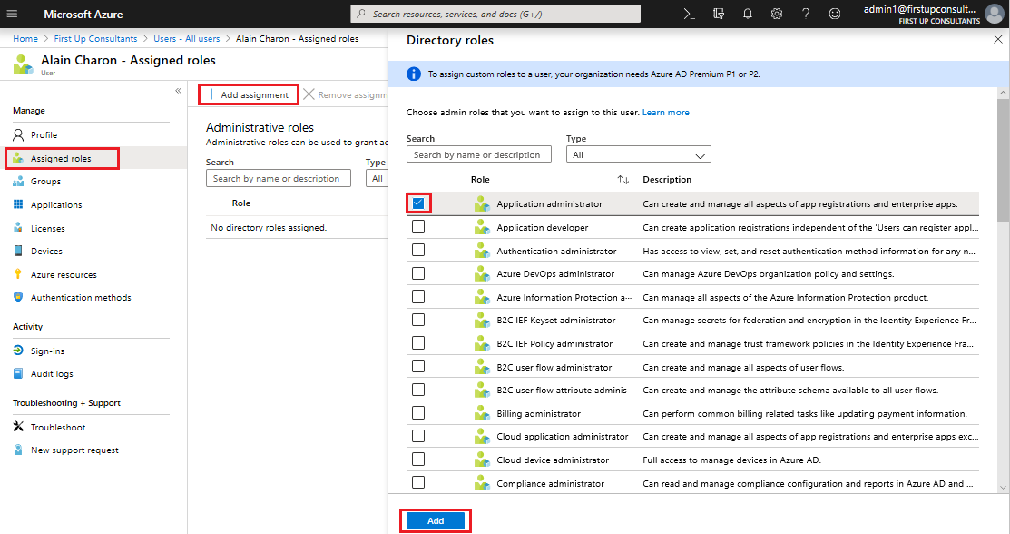

The Application administrator role is assigned to Alain Charon and it appears on the **Alain Charon - Directory role** page.

## Remove a role assignment

If you need to remove the role assignment from a user, you can also do that from the **Alain Charon - Directory role** page.

### To remove a role assignment from a user

1. Select **Azure Active Directory**, select **Users**, and then search for and select the user getting the role assignment removed. For example, Alain Charon.
2. Select **Assigned roles**, select **Application administrator**, and then select **Remove assignment**.

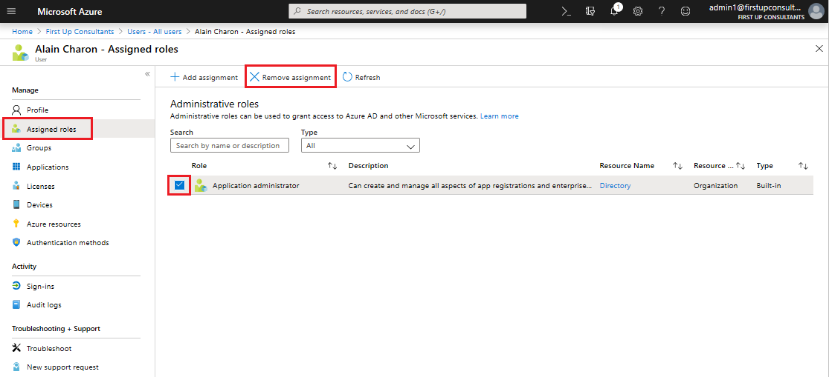

The Application administrator role is removed from Alain Charon and it no longer appears on the **Alain Charon - Directory role** page.

**Connect-AzAccount**

**New-AzResourceGroup -Name UKSRG1 -Location "UK South"**

## Sign in to Azure

Sign in to the [Azure portal](https://portal.azure.com/).

## Create a virtual network

1. From the Azure portal menu, select **Create a resource**.
2. From the Azure Marketplace, select **Networking** > **Virtual network**.
3. In **Create virtual network**, enter or select this information:

| **Setting** | **Value** |
| --- | --- |
| Name | Enter myVirtualNetwork. |
| Address space | Enter 10.1.0.0/16. |
| Subscription | Select your subscription. |
| Resource group | Select **Create new**, enter myResourceGroup, then select **OK**. |
| Location | Select **East US**. |
| Subnet - Name | Enter myVirtualSubnet. |
| Subnet - Address range | Enter 10.1.0.0/24. |

1. Leave the rest as default and select **Create**.

## Create virtual machines

Create two VMs in the virtual network:

### Create the first VM

1. From the Azure portal menu, select **Create a resource**.
2. From the Azure Marketplace, select **Compute** > **Windows Server 2019 Datacenter**.
3. In **Create a virtual machine - Basics**, enter or select this information:

| **Setting** | **Value** |
| --- | --- |
| **PROJECT DETAILS** |  |
| Subscription | Select your subscription. |
| Resource group | Select **myResourceGroup**. You created this in the previous section. |
| **INSTANCE DETAILS** |  |
| Virtual machine name | Enter myVm1. |
| Region | Select **East US**. |
| Availability options | Leave the default **No infrastructure redundancy required**. |
| Image | Leave the default **Windows Server 2019 Datacenter**. |
| Size | Leave the default **Standard DS1 v2**. |
| **ADMINISTRATOR ACCOUNT** |  |
| Username | Enter a username of your choosing. |
| Password | Enter a password of your choosing. The password must be at least 12 characters long and meet the [defined complexity requirements](https://docs.microsoft.com/en-us/azure/virtual-machines/windows/faq?toc=%2fazure%2fvirtual-network%2ftoc.json#what-are-the-password-requirements-when-creating-a-vm). |
| Confirm Password | Reenter password. |
| **INBOUND PORT RULES** |  |
| Public inbound ports | Leave the default **None**. |
| **SAVE MONEY** |  |
| Already have a Windows license? | Leave the default **No**. |

1. Select **Next : Disks**.
2. In **Create a virtual machine - Disks**, leave the defaults and select **Next : Networking**.
3. In **Create a virtual machine - Networking**, select this information:

| **Setting** | **Value** |
| --- | --- |
| Virtual network | Leave the default **myVirtualNetwork**. |
| Subnet | Leave the default **myVirtualSubnet (10.1.0.0/24)**. |
| Public IP | Leave the default **(new) myVm-ip**. |
| Public inbound ports | Select **Allow selected ports**. |
| Select inbound ports | Select **HTTP** and **RDP**. |

1. Select **Next : Management**.
2. In **Create a virtual machine - Management**, for **Diagnostics storage account**, select **Create New**.
3. In **Create storage account**, enter or select this information:

| **Setting** | **Value** |
| --- | --- |
| Name | Enter myvmstorageaccount. If this name is taken, create a unique name. |
| Account kind | Leave the default **Storage (general purpose v1)**. |
| Performance | Leave the default **Standard**. |
| Replication | Leave the default **Locally-redundant storage (LRS)**. |

1. Select **OK**
2. Select **Review + create**. You're taken to the **Review + create** page where Azure validates your configuration.
3. When you see the **Validation passed** message, select **Create**.

### Create the second VM

1. Complete steps 1 and 9 from above.

**Note**

In step 2, for the **Virtual machine name**, enter myVm2.

In step 7, for **Diagnosis storage account**, make sure you select **myvmstorageaccount**.

1. Select **Review + create**. You're taken to the **Review + create** page and Azure validates your configuration.
2. When you see the **Validation passed** message, select **Create**.

## Connect to a VM from the internet

After you've created myVm1, connect to the internet.

1. In the portal's search bar, enter myVm1.
2. Select the **Connect** button.

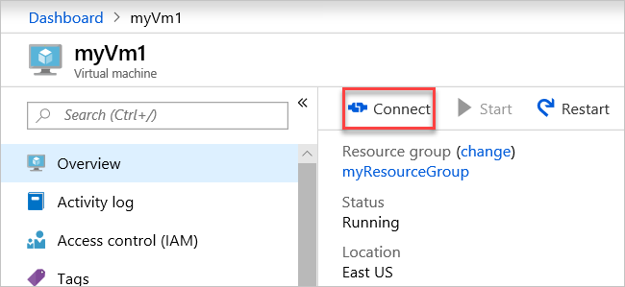

After selecting the **Connect** button, **Connect to virtual machine** opens.

1. Select **Download RDP File**. Azure creates a Remote Desktop Protocol (.rdp) file and downloads it to your computer.
2. Open the downloaded .rdp file.
   1. If prompted, select **Connect**.
   2. Enter the username and password you specified when creating the VM.

**Note**

You may need to select **More choices** > **Use a different account**, to specify the credentials you entered when you created the VM.

1. Select **OK**.
2. You may receive a certificate warning during the sign in process. If you receive a certificate warning, select **Yes** or **Continue**.
3. Once the VM desktop appears, minimize it to go back to your local desktop.

## Communicate between VMs

1. In the Remote Desktop of myVm1, open PowerShell.
2. Enter ping myVm2.

You'll receive a message similar to this:

Pinging myVm2.0v0zze1s0uiedpvtxz5z0r0cxg.bx.internal.clouda

Request timed out.

Request timed out.

Request timed out.

Request timed out.

Ping statistics for 10.1.0.5:

Packets: Sent = 4, Received = 0, Lost = 4 (100% loss),

The ping fails, because ping uses the Internet Control Message Protocol (ICMP). By default, ICMP isn't allowed through the Windows firewall.

1. To allow myVm2 to ping myVm1 in a later step, enter this command:
2. New-NetFirewallRule –DisplayName "Allow ICMPv4-In" –Protocol ICMPv4

This command allows ICMP inbound through the Windows firewall:

1. Close the remote desktop connection to myVm1.
2. Complete the steps in [Connect to a VM from the internet](https://docs.microsoft.com/en-us/azure/virtual-network/quick-create-portal#connect-to-a-vm-from-the-internet) again, but connect to myVm2.
3. From a command prompt, enter ping myvm1.

You'll get back something like this message:

Pinging myVm1.0v0zze1s0uiedpvtxz5z0r0cxg.bx.internal.cloudapp.net [10.1.0.4] with 32 bytes of data:

Reply from 10.1.0.4: bytes=32 time=1ms TTL=128

Reply from 10.1.0.4: bytes=32 time<1ms TTL=128

Reply from 10.1.0.4: bytes=32 time<1ms TTL=128

Reply from 10.1.0.4: bytes=32 time<1ms TTL=128

Ping statistics for 10.1.0.4:

Packets: Sent = 4, Received = 4, Lost = 0 (0% loss),

Approximate round trip times in milli-seconds:

Minimum = 0ms, Maximum = 1ms, Average = 0ms

You receive replies from myVm1, because you allowed ICMP through the Windows firewall on the myVm1 VM in step 3.

1. Close the remote desktop connection to myVm2.

## Clean up resources

When you're done using the virtual network and the VMs, delete the resource group and all of the resources it contains:

1. Enter myResourceGroup in the **Search** box at the top of the portal and select **myResourceGroup** from the search results.
2. Select **Delete resource group**.
3. Enter myResourceGroup for **TYPE THE RESOURCE GROUP NAME** and select **Delete**.